**Project Planning**

What you have done on the Project so far?

* Research about reasons of UN-Migration.
* Decided on the project title and country (USA)
* Decided on the factors of ASIANS migration rate increase in USA

What you plan to complete before the next stand-up?

The project drafts which include charts, datasets and documentations related to the Asians migration rate increase in USA.

What obstacles you are facing in completing your deliverables?

Searching for datasets.

**Time and Day of Regular Meeting Slot**

Wednesday & Saturday 3pm.

**Summary of To-Dos before Next Meeting**

Research on the reasons of why the population rate of Asians are increasing in USA throughout the years. What are the reasons for them to migrate into America.

**GitHub Repository**

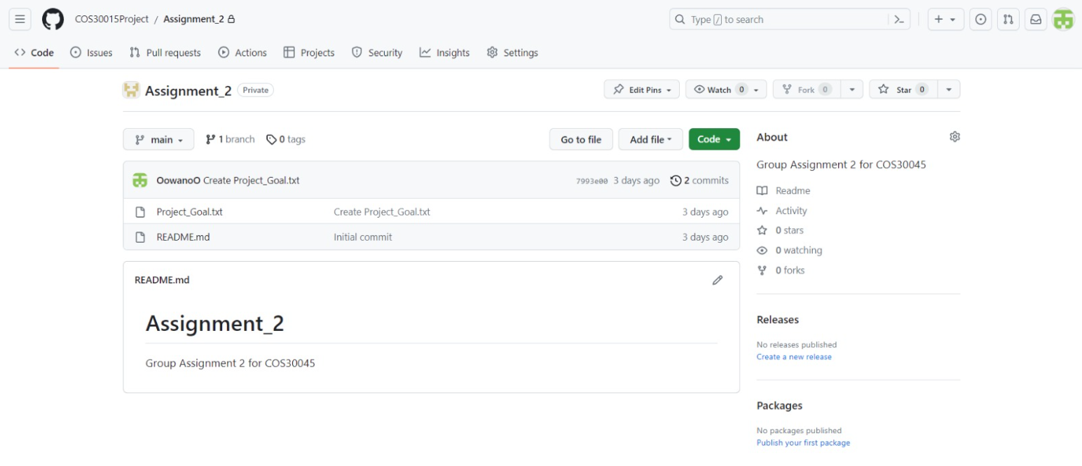

**Communication Channel**

Discord:



**Shared Drive/Documentation**

<https://www.un.org/en/global-issues/migration>

<https://population.un.org/dataportal/home>

<https://www.migrationpolicy.org/article/chinese-immigrants-united-states>

<https://data.worldbank.org/indicator/SM.POP.NETM?end=2021&locations=CN&start=2021&view=map>

**Project Schedule**

We will start the project starting from next week (18th Sep 2023)

**Any issues with teamwork**

None.